Attention: This will be a dynamic document. I will add material leading up to the test.
Mr. Carpenter
AP Government
Unit One Topics and Themes
- Social Contract
- Locke
- Natural Rights
- Hobbes
- Paine
- Democratic Theory
- Authoritarian v. Democracy
- Direct v. Representative Democracy
- Declaration of Independence
- First and Second Continental Congress
- Articles of Confederation (Basis and Weaknesses)
- Transition Period/Constitutional Convention
- Annapolis Convention
- Philadelphia Convention
- Plans/Compromises
- Shays’ Rebellion
- Federalist Papers/Feds v. Anti-feds
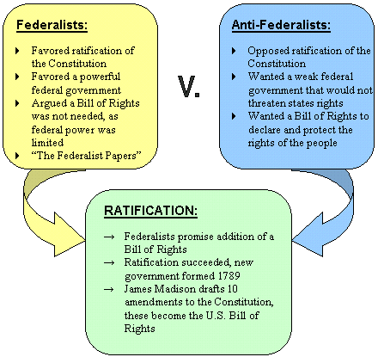
- Elitism and Pluralism
Pluralism
The Pluralist Theory involves a stress on immaterial power. Power can be in the form of many ideals such as political, religious, skilled or even persuasive power. This power is to be distributed to all members of the social contract; nobody is to have more or less say in the institution than any other. The Pluralist Theory goes even farther to suggest that no one controls the social contract as everyone has such an equal state in it. While some theories argue as to how a system should be run and who should be the head of said system, the Pluralist Theory challenges by arguing there be any system, let alone a head of a system, at all. Potential Power is also a recurring theme between the two theories, and Potential Power, like abilities of the people, shall always outweigh the actual Present Power, such as Executive Rulers or rights of a central power. Hyper pluralism is one of the great weaknesses of pluralism. It happens when the pluralistic society feels as if it doesn't give the people enough power and so they rise up against the government. It results in a complete crippling of government as the government bends to the will of all the interest groups.

Elitism
Elitism is a stress on material power. Those who have resources must be successful and rightful rulers, or else that resource would not have gotten into their possession. Superiority in the elites is the premise for the Elitist Theory. Whoever has achieved must be of a higher mental capacity, and therefore are the only ones who are worthy of a position of power. To Elitists, the common people are common due to a lack of superiority. Elitism recognizes the need for people to be governed, and decides that elitists should rule because of all the material power around, they have the most, and therefore have the most to be lost in the event of an unsuccessful social contract. By making those with the most possession the ones in power, it is theorized that there will be order due to the elites keeping it together in order to sustain their foothold in society.
- The Constitution
- Structure and function
- Delegated, Reserved, Concurrent, and Prohibited Powers
- The United States federal system divides power between national and state governments, both of which govern the same constituents. The powers granted to the national government in the Constitution are called delegated powers. There are three types of delegated powers: enumerated powers, implied powers, and inherent powers. Enumerated powers, sometimes called expressed powers, are given directly by the Constitution. Examples of these powers include the power to declare war, regulate foreign and interstate commerce, conduct foreign relations, coin money, and raise and maintain a military (Article 1, Section 8).
- Inherent powers, although not expressly delegated by the Constitution, are powers that are intrinsically held by any national government of a sovereign state. Examples of inherent powers include the power to control immigration, the power to acquire territory, and the power to quell insurrections.

- The powers granted to the state governments are reserved powers. These are powers that are not given to the national government, but which are not denied to the states. These reserved powers are collectively known as the "police power" of the state. Powers that are shared by both the national and state governments are concurrent powers. Examples include the power to tax, borrow money, and define crimes and punish criminals.

- There are several powers that are denied either to national, state, or both governments. Powers that are given to the state governments may be denied to the national government, and vice versa. Examples of powers that are denied to the states are the power to coin money, make treaties, and wage war. The national government cannot make new states without the consent of the state legislature concerned, nor can they try anyone for treason without two witnesses and/or a confession.

- A recurring debate concerning federalism is the question of which government's power is supreme regarding disputes between state and national governments. Article VI of the Constitution, referred to as the supremacy clause, states that there are three items that are the superlative law of the land: the Constitution, the laws of the national government which are not otherwise unconstitutional, and treaties, which can only be formed by the national government.

- Although the supremacy clause gives the national government supreme powers, boundaries to those powers are provided in the Tenth Amendment to the Constitution. This amendment gives the states those powers that are not delegated to the national government, nor prohibited to the states. Therefore, the Tenth Amendment became the states' guarantee to rights and the source of the state governments' reserved powers. This amendment clearly defines the eighteenth century concept of dual federalism: shared power with separated spheres of influence.

- Federalism in the United States has been an evolutionary process. Three key issues have determined how national and state powers are balanced: implied powers, commerce power, and the Civil War.
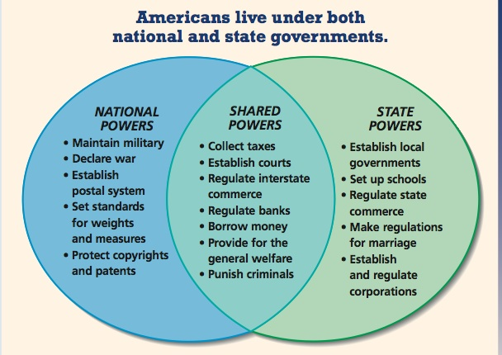
- Checks and balances
- Separation of Powers
- Necessary and Proper Clause/McCulloch v, Maryland (68)
Under Article I, Section 8 of the Constitution, Congress has the power "to make all Laws which shall be necessary and proper for carrying into Execution the foregoing Powers, and all other Powers vested by this Constitution in the Government of the United States, or any Department or Officer thereof".
The necessary and proper clause is a constitutional compromise, one somewhere between the Federalist disposition not to enumerate any Congressional powers at all—a vital part of a wholly national arrangement—and the Antifederalist concern to limit the reach of Congress to those items expressly itemized
In McCulloch v. Maryland (1819) the Supreme Court ruled that Congress had implied powers under the Necessary and Proper Clause of Article I, Section 8 of the Constitution to create the Second Bank of the United States and that the state of Maryland lacked the power to tax the Bank. Arguably Chief Justice John Marshall's finest opinion, McCulloch not only gave Congress broad discretionary power to implement the enumerated powers, but also repudiated, in ringing language, the radical states' rights arguments presented by counsel for Maryland.
- Nullification
Nullification is the formal suspension by a state of a federal law within its borders. The concept was first given voice by Thomas Jefferson and James Madison, in opposition to the Alien and Sedition Acts. The principle was accepted by the Hartford Convention of New Englanders in 1814 as well as many in the South, who saw it as protection against federal encroachment on their rights. It remained a point of contention and reached a crisis in 1832
- Commerce Clause/Gibbons v. Ogden
Gibbons v. Ogden (1824) vastly expanded the powers of Congress through a single clause in the Constitution: the Commerce Clause of Article I, Section 8. The Court ruled that under that clause Congress had powers to regulate any aspect of commerce that crossed state lines, including modes of transportation, and that such regulation preempted conflicting regulation by the states. Since Gibbons, the Commerce Clause has provided the basis for sweeping congressional power over a multitude of national issues.
- Federalism-Form of government in which a constitution distributes power between central government and subdivisional products (states). The powers are clearly defined for both the state and national government
- Dual, Cooperative, Marble Cake, Competitive, and Permissive (p58-59))
- Checks and Balances (30)
- Separation of Powers (28)
- Grants (72-73)
- Mandates (74)
- Full Faith and Credit Clause (66)
- Interstate Relations (66-68)
- Extradition (67)
- National Supremacy (69)

