Types of Federalism
Edit 0 23…

Writers: Julia Levine and Trevi Yavorek

Editor: Taylor Bond

Types of Federalism:
What is Federalism?

Federalism has impacted and shaped American government from its very beginnings. Over the course of American history, federalism has constantly shifted and changed forms, never allowing the different branches of government to retain the same powers or rights, outside of what the Constitution guarantees. Many different types of federalism exist, in both the world and in past and present American government. Federalism is defined as a form of government in which a grouping of states or different groups are under the ruling of one, central power. In a federal form of government, both the national and state governments receive their power from the people. The early Federalists in America in the era preceding the independence of the colonies from Britain favored a strong national government, and would support the powers allocated to the central government in the Constitution. These federalists approved of a powerful central government, particularly with a bicameral legislature, and supported the manner in which federalism kept the direct power to rule out of the common man’s hands, who they did not see fit to govern the nation. As time has passed, the views of federalism and federalists have changed, along with the type of federalism present in the United States.
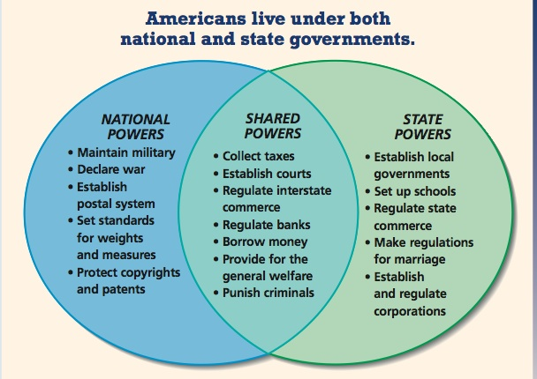
http://mrkash.com/activities/images/federalism.jpg

How does this diagram represent federalism? This diagram displays the powers given to both the
states and the nation government along with the shared power.
Dual Federalism

Dual Federalism was the belief of having separate but equally powerful branches and levels of government, in which the state and national levels would both have a lot of power to balance each other out. Some ways in which this balance was achieved was by what is known as the concurrent powers. In these powers, the powers are shared between the state and federal government. However, as federalism and the nation evolved over time, these concurrent powers blurred and the distinction between them became less clear. This type of federalism is known as "layer cake federalism."
Cooperative Federalism

Cooperative Federalism was the belief of all the levels of government working together cooperatively to achieve and solve common problems. This type of federalism was most popular in the 1930’s, following the Great Depression, and lasted up until the 1970’s. In this time period, miscommunication or power struggles between state and national government could not be afforded during the nation’s time of need. The nation needed the government to take control of the situation and fix the present problems, such as the economy. Government funded programs were implemented nationwide to attempt to fix the nation, such as the WPA and REA. As the central government needed a unified plan of action for all of America, certain boundaries that had typically been reserved for the states in the past had to be crossed. Because of this, the distinction between federal and state powers became less defined, resulting in what is known as “marble cake federalism”.

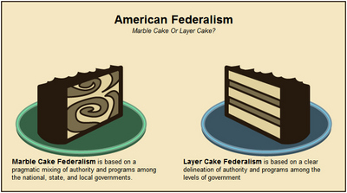
http://apgovt.wikispaces.com/file/view/Federalism.jpg/30992839/Federalism.jpg

How does cake symbolize federalism? The two different cakes show two different types of federalism. The marble (swirly) cake signifies cooperative federalism, where the powers are not divided, but are shared by all levels of government. The layer cake represents duel federalism. The different layers symbolize the distinct, different powers the states' government and the national government have.
Creative Federalism

Creative Federalism was the type of federalism that shifted more power towards the national government by bypassing state governments and allowing the federal government to have direct control over statewide programs. This form of federalism is also know as "picket-fence federalism", and was most prevalent during the terms of Lyndon Johnson and his Great Society. The national government began to interfere more in welfare programs in an effort to make a stride towards a better nation, and alleviate some of the problems the nation was faced with at the time. In this era, the state government was generally overlooked as the national government decreed what was to be done in the states, directly affecting the local governments and the citizens of the state. The power of the states weakened during this type of federalism. Grants were used as a way to coerce the state governments into complying with the national government's wishes.
New Federalism

New Federalism evolved with the election of Ronald Reagan in the 1980s. In this progression of federalism, more power was returned to the state in an effort to even out the balance of strength between the national and state governments. One way this shift in balance was achieved was block grants. Block grants were essentially grants to the state governments with little description or restrictions on how to handle the money. In this way, the national government was in essence giving states funds for basically whatever they wanted.

Along with New Federalism was the “Devolution Revolution”, which was another drive to give more power back towards the state government. The Devolution Revolution had a significant stride in the reformation of unfunded mandates. Unfunded mandates were issues from the national government to the state governments to comply with a certain order without offering funds to aid the states in achieving the national government’s requirement. By preventing Congress from passing potentially costly federal programs and no allocating the state governments funds to carry out Congress’s wishes, more power was returned to the states.
Federalism Under President Bush

Bush Federalism, although not an actual form of federalism, showcased important events and changes in American history and drastically changed the type of federalism in our nation’s government. The federalism under George W. Bush’s terms gave an extreme amount of power to the national government, as unity and control was needed during the times of need the nation in this era. Catastrophes such as 9/11 and the war on terrorism called for a stronger, more powerful central government to deal with the nations issues. Additionally, acts such as No Child Left Behind were viewed as an extreme version of preemption, or when the national government overrides state and local government, giving more power to the national government.
Judicial Federalism

Judicial Federalism is the ability of the Supreme Court and judicial review to influence the type of federalism during a certain era, mainly because of their ability to rule on whether something is constitutional or not. This ability invested in the Supreme Court allows the court to decide where the power of government goes; either to the stat

e or to the central government. The members of the Supreme Court can allocate where the power goes, based on their views of the Constitution and how they chose to rule on a matter.
Fiscal Federalism

Fiscal Federalism is the usage of funds from the federal government to the states in order to support a national program. A prime example of fiscal federalismare categorical grants, in which the national government gives states money with requirements attached. Fiscal federalism, and how it is applied, like judicial federalism, can have a great impact on the type of federalism present during that time. The manner in which the money is distributed can shape the federalism in that era. As previously mentioned, unfunded mandates and block grants are other ways in which fiscal federalism can be represented.
Progressive Federalism

Progressive Federalism is a recent form of federalism employed by the Obama administration which allows the states to have a greater control over issues normally reserved for the national government. In various instances, states have been able to enforce more regulations on government decrees than necessary. This type of federalism is used in different situations, such as California imposing stricter regulations on the emissions of greenhouse gases in vehicles. This allows the states to still comply with government orders, but add their own additions as well. Allowing states to experiment with different variations on the same government mandate can inform the national government on which type of changes are most effective, and can allow the national government to tailor their own laws to make them, in turn, more effective based off of what the different states discovered.
Other Types of Federalism

Many types of federalism can exist. Federalism changes every generation, each new type shaping the nation during that time. The types of federalism mentioned above are only the tip of the iceberg, and the most famous kinds. A different type of federalism can be created for practically any shift in the way the power of the nation is redistributed. While the most well-known are described above, other kinds of federalism do exist, such as
- Vertical Federalism-the view of the central government having the supreme power over the land
- Horizontal Federalism-the view of the interactions and power being shared between the states in America
- Contemporary Federalism-the type of federalism occurring in modern times, accommodating the shifting relationships between nation and state, growth of the fiscal nature of federalism, and debating ideas on the limit of the national government's power

VOCABULARY
Federalism- a form of government where a group of states, territories, etc., are governed by one central power.
Federalists- a member of the Federalist party
Dual Federalism-the federal government and the states’ government have separate, but equal, powers. Also known as “layer cake federalism”
Cooperative Federalism-Both the federal and states’ governments share equal powers when it comes to the nation. Often called “marble cake federalism”
New Federalism- federalism during the Reagan era; more power was given to the states' government
Block grants-grants giving to state governments with little restrictions on how to handle the money
Unfunded mandates- issues from the national government to the state governments, following a certain order without offering funds to aid the states in achieving the national government’s requirement
Judicial Federalism- when Supreme Court and the Judiciary have the ability to influence federalism.
Fiscal Federalism- Federalism where the use of funds help support a national program.
Progressive Federalism- most recent form of federalism; allows states to have greater control over certain powers usually reserved for the national government.
REVIEW QUESTIONS:
1.What is federalism?
2. Which two types of federalism are mentioned above?
3. Dual Federalism is the belief of...?
4. Marble Cake Federalism is...?
5. T/F Marble Cake and Layer Cake Federalism are two ways to say the same thing.
6. The Devolution Revolution is...?
7. In Bush Federalism, the power of the central government...?

